<https://en.wikipedia.org/wiki/List_of_national_anthems>

<https://en.wikipedia.org/wiki/List_of_historical_national_anthems>

<https://musicinformationretrieval.com/index.html>

<https://www.musical-u.com/learn/rhythm-tips-for-identifying-music-genres-by-ear/>

<https://learningmusic.ableton.com/make-beats/tempo-and-genre.html>

<http://www.aede-france.org/Anthems-and-flags.html>

“you are what you stream,”:

Songs are analyzed based on their digital signatures for some factors, including tempo, acoustics, energy, danceability, etc. to answer that impossible old first-date query: What kind of music are you into?

Fun Time: Linkin Park Vs Micheal Jackson Vs Blue Lets compare the Spectrograms for three very popular songs:

I believe that most people are likely to have greater skills in visual than musical tracking because it’s exercised more frequently in daily life. However, musical decomposition and tracking is a learnable skill and having a visual aid such as a “visual piano roll” grants listeners of all experiences enhanced abilities to focus on parts of a musical performance.

Vox’s “Earworm” series

<https://towardsdatascience.com/a-music-taste-analysis-using-spotify-api-and-python-e52d186db5fc>

<https://dev.to/ericbonfadini/finding-my-new-favorite-song-on-spotify-4lgc>

<https://musicinformationretrieval.com/index.html>

<http://www2.imm.dtu.dk/pubdb/edoc/imm3851.pdf>

<http://stevemorphet.weebly.com/speech-and-audio-processing/speech-and-audio-processing-part-2>

<https://bastian.rieck.me/blog/posts/2014/simple_experiments_speech_detection/>

<https://www.kdnuggets.com/2020/02/audio-data-analysis-deep-learning-python-part-1.html>

0) <https://towardsdatascience.com/understanding-audio-data-fourier-transform-fft-spectrogram-and-speech-recognition-a4072d228520>

1) <https://towardsdatascience.com/a-visual-look-at-my-taste-in-music-a8c197a728be>

2) <https://towardsdatascience.com/bringing-songs-to-life-through-music-visualization-8beee9573b7b> (JS)

3) <https://mschermann.github.io/data_viz_reader/patterns.html> (generic visualization)

4) <https://flystarhe.github.io/docs-2018/python/video/Sound_visualization/> (extra)

5) librosa

* <https://levelup.gitconnected.com/audio-data-analysis-using-deep-learning-part-1-7f6e08803f60>
* <https://towardsdatascience.com/music-genre-classification-with-python-c714d032f0d8>
* <https://heartbeat.fritz.ai/working-with-audio-signals-in-python-6c2bd63b2daf>

7) <https://medium.com/nightingale/data-visualization-in-music-11fcd702c893> (only wow)

<https://panthema.net/2013/1024-Sound-of-Sorting-KIT-Informatik/>

<https://www.youtube.com/watch?v=HzzmqUoQobc&feature=youtu.be>

8) <https://wiki.python.org/moin/PythonInMusic>(all lib)

9) <https://www.serendipidata.com/posts/visualizing-musical-data>

10) <https://www.kaggle.com/deepaksinghrawat/in-depth-introduction-to-audio-for-beginners>

11)<https://medium.com/@ajlabs/how-and-why-we-made-our-first-audio-data-visualisation-ed7c136327ae>

<https://www.analyticsvidhya.com/blog/2017/08/audio-voice-processing-deep-learning/>

12) Highlights

<https://towardsdatascience.com/generate-any-sport-highlights-using-python-3695c98baead>

mashup artist in the world. His music (like mine) is a combination of other songs edited into a seamless collage that becomes categorically new and different from the sum of its parts

Vox’s “Earworm” series is totally worth your time. In fact, my entryway into the series was their fantastic description behind “the most feared song in Jazz” — Giant Steps by John Coltrane.

In general, there are two basic types of data visualisation: exploration, which helps find a story the data is telling you, and explanation, which tells a story to an audience. Both types of data visualisation must take into account the audience’s expectations.

In general, there are two basic types of data visualisation: exploration, which helps find a story the data is telling you, and explanation, which tells a story to an audience. Both types of data visualisation must take into account the audience’s expectations.

**Polar area diagrams are useful for representing seasonal or cyclical time series data, such as climate or seasonal crop data. Multiple variables can be neatly stacked in the various sectors of the pie.**

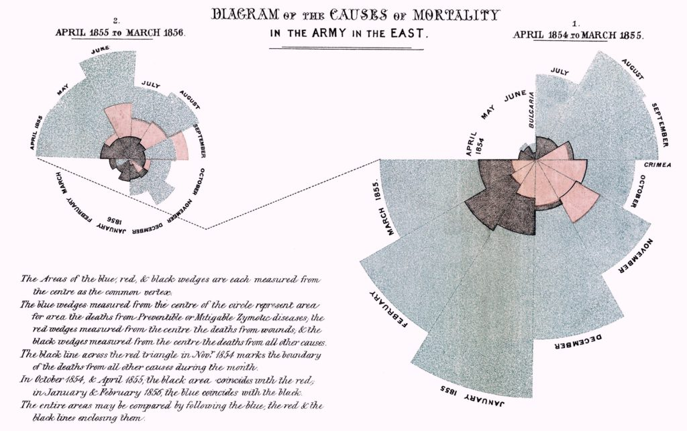

**The old adage “a picture is worth a thousand words” takes on an even greater importance because, with data, someone coming to their own conclusion about its implications is much more powerful than telling them the finding.**